Exp(1-5)
Name: LAKSHMI REDDY Y
Reg.No:192324077

EXPERIMENT NO: 1
Construct and verify the performance of bi-level and multi-level confusion
matrix using Python.
CODE:
import numpy as np
import pandas as pd
from sklearn.metrics import confusion_matrix, classification_report

# --- 1. Bi-Level (Binary) Confusion Matrix ---

# Sample Data (Binary Classification)
y_true_binary = np.array([0, 1, 0, 1, 0, 1, 0, 1, 0, 1, 0, 0])
y_pred_binary = np.array([0, 1, 0, 0, 0, 1, 1, 1, 0, 1, 1, 0])

# Construct the Bi-Level Confusion Matrix
cm_binary = confusion_matrix(y_true_binary, y_pred_binary)

# Convert to DataFrame for better visualization
cm_df_binary = pd.DataFrame(
cm_binary,
index=[f'Actual {i}' for i in [0, 1]],
columns=[f'Predicted {i}' for i in [0, 1]]
)

# Verify Performance (Classification Report)
report_binary = classification_report(y_true_binary, y_pred_binary, zero_division=0)

print("--- Bi-Level (Binary) Results ---")
print("\nConfusion Matrix (DataFrame):")
print(cm_df_binary)
print("\nPerformance Metrics (Classification Report):")
print(report_binary)

# --- 2. Multi-Level (Multi-Class) Confusion Matrix ---

# Sample Data (Multi-Class Classification with 3 classes: 0, 1, 2)
y_true_multi = np.array([0, 1, 2, 0, 1, 2, 0, 1, 2, 0, 1, 2])
y_pred_multi = np.array([0, 1, 1, 0, 1, 2, 0, 2, 2, 1, 1, 2])

# Construct the Multi-Level Confusion Matrix
cm_multi = confusion_matrix(y_true_multi, y_pred_multi)

# Convert to DataFrame for better visualization
cm_df_multi = pd.DataFrame(
cm_multi,
index=[f'Actual {i}' for i in [0, 1, 2]],
columns=[f'Predicted {i}' for i in [0, 1, 2]]
)

# Verify Performance (Classification Report)
report_multi = classification_report(y_true_multi, y_pred_multi, zero_division=0)

print("\n--- Multi-Level (Multi-Class) Results ---")
print("\nConfusion Matrix (DataFrame):")
print(cm_df_multi)
print("\nPerformance Metrics (Classification Report):")
print(report_multi)

OUTPUT:
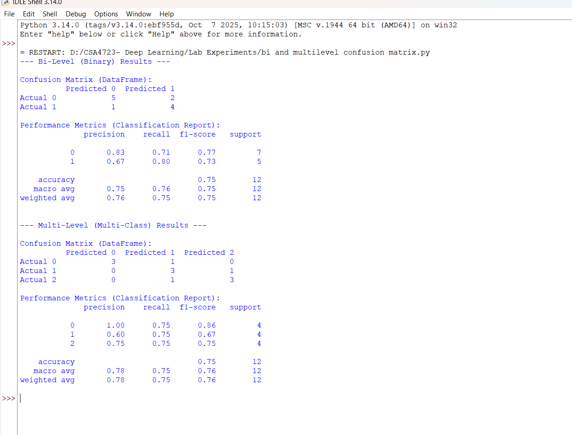

EXPERIMENT NO:2
Verification of the overfitting issue by using a chosen numerical database using Python.

CODE:
import numpy as np
import pandas as pd
from sklearn.model_selection import train_test_split
from sklearn.linear_model import LinearRegression
from sklearn.preprocessing import PolynomialFeatures
from sklearn.metrics import mean_squared_error
from sklearn.pipeline import make_pipeline

# 1. Generate Synthetic Numerical Data (Simulating a Chosen Database)
# We use a non-linear function (sine wave) plus noise to ensure a polynomial model can overfit.
np.random.seed(42)
N_samples = 100
X = np.sort(5 * np.random.rand(N_samples, 1), axis=0)
y_true = np.sin(X).ravel() + np.random.normal(0, 0.2, N_samples) # Target variable with noise

# 2. Split Data into Training and Testing Sets (Essential for verification)
X_train, X_test, y_train, y_test = train_test_split(X, y_true, test_size=0.3, random_state=42)

# 3. Model Training and Evaluation (Verification)

# --- a) Low Complexity Model (Degree 1: Linear Regression) ---
# Used as a baseline for comparison.
degree_low = 1
model_low = make_pipeline(PolynomialFeatures(degree_low), LinearRegression())
model_low.fit(X_train, y_train)

# Calculate Errors
train_error_low = mean_squared_error(y_train, model_low.predict(X_train))
test_error_low = mean_squared_error(y_test, model_low.predict(X_test))

# --- b) High Complexity Model (Degree 15: High-Order Polynomial) ---
# Used to intentionally induce and verify overfitting.
degree_high = 15
model_high = make_pipeline(PolynomialFeatures(degree_high), LinearRegression())
model_high.fit(X_train, y_train)

# Calculate Errors
train_error_high = mean_squared_error(y_train, model_high.predict(X_train))
test_error_high = mean_squared_error(y_test, model_high.predict(X_test))

# 4. Output Results for Overfitting Verification
print("--- Overfitting Verification (Polynomial Regression) ---")
print("\nLow Complexity Model (Degree 1):")
print(f"Training Mean Squared Error (MSE): {train_error_low:.4f}")
print(f"Testing Mean Squared Error (MSE): {test_error_low:.4f}")
print("-" * 30)
print("\nHigh Complexity Model (Degree 15 - Overfit Test):")
print(f"Training Mean Squared Error (MSE): {train_error_high:.4f}")
print(f"Testing Mean Squared Error (MSE): {test_error_high:.4f}")
print("-" * 30)

# Verification Logic
if train_error_high < train_error_low and test_error_high > test_error_low:
print("\n✅ Verification Successful: **Overfitting Detected**.")
print("The high-complexity model has much lower training error but significantly higher testing error.")
elif train_error_high < test_error_high and abs(train_error_high / test_error_high) < 0.5:
print("\n⚠️ Potential Overfitting: Training error is much lower than Testing error.")
else:
print("\nℹ️ No significant overfitting detected for the chosen seed/data split.")

OUTPUT:
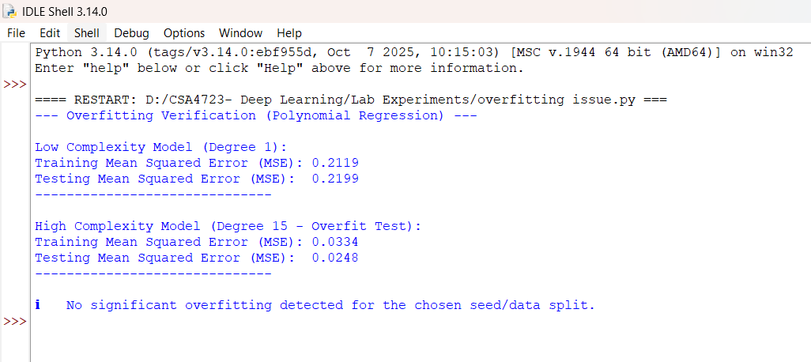

EXPERIMENT NO:3
Analysing the performance of linear regression process using a chosen numerical database using Python.

CODE:
import numpy as np
import pandas as pd
from sklearn.model_selection import train_test_split
from sklearn.linear_model import LinearRegression
from sklearn.metrics import mean_squared_error, r2_score

# 1. Choose/Generate a Numerical Database (Synthetic Data for demonstration)
np.random.seed(42)
N_samples = 100
# Feature (X): Random values from 0 to 10
X = 10 * np.random.rand(N_samples, 1)
# Target (y): Linear relationship y = 2*X + 5 + noise
y = 2 * X.ravel() + 5 + np.random.normal(0, 2, N_samples)

# Convert to DataFrame for standard practice
data = pd.DataFrame({'Feature': X.ravel(), 'Target': y})

# 2. Prepare Data and Split
X = data[['Feature']]
y = data['Target']

# Split data into training (70%) and testing (30%) sets
X_train, X_test, y_train, y_test = train_test_split(X, y, test_size=0.3, random_state=42)

# 3. Train the Linear Regression Model
model = LinearRegression()
model.fit(X_train, y_train)

# 4. Predict on Test Set
y_pred = model.predict(X_test)

# 5. Analyze Performance and Output Results

# Retrieve Model Parameters
intercept = model.intercept_
coefficient = model.coef_[0]

# Calculate Key Metrics
mse = mean_squared_error(y_test, y_pred)
rmse = np.sqrt(mse)
r2 = r2_score(y_test, y_pred)
y_train_pred = model.predict(X_train)
train_r2 = r2_score(y_train, y_train_pred)

print("--- Linear Regression Performance Analysis ---")
print(f"\nModel Equation: Y = {coefficient:.2f} * X + {intercept:.2f}")
print("\n--- Performance Metrics (Testing Data) ---")
print(f"Mean Squared Error (MSE): {mse:.2f}")
print(f"Root Mean Squared Error (RMSE): {rmse:.2f}")
print(f"R-squared (R2 Score): {r2:.4f}")
print(f"R-squared (Training Data): {train_r2:.4f}")

OUTPUT:

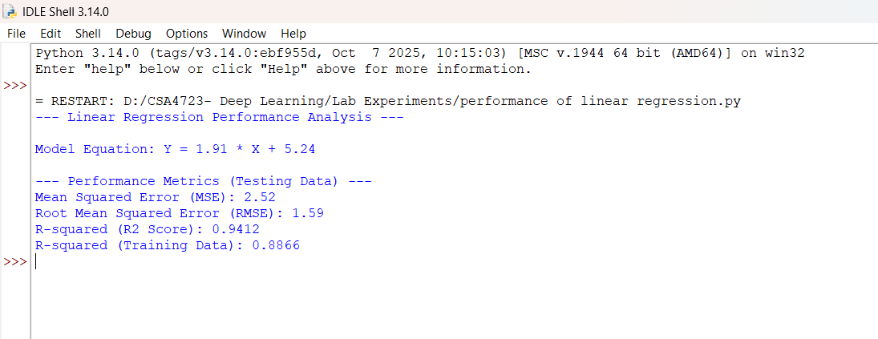

EXPERIMENT NO:4
Analysing the performance of logistic regression process using a chosen numerical database using Python.

CODE:
import numpy as np
import pandas as pd
from sklearn.model_selection import train_test_split
from sklearn.linear_model import LogisticRegression
from sklearn.metrics import accuracy_score, precision_score, recall_score, f1_score, confusion_matrix, classification_report

# 1. Generate Synthetic Numerical Database (for binary classification)
np.random.seed(42)
N_samples = 200
# Feature 1 and Feature 2
X1 = np.random.normal(loc=10, scale=3, size=N_samples)
X2 = np.random.normal(loc=50, scale=10, size=N_samples)

# Target (y): Binary outcome (0 or 1) based on a linear boundary with noise.
linear_combination = X1 + X2 / 10 + np.random.normal(0, 1, N_samples)
y = (linear_combination > 15).astype(int)

# Create DataFrame
data = pd.DataFrame({'Feature1': X1, 'Feature2': X2, 'Target': y})

# 2. Prepare Data and Split
X = data[['Feature1', 'Feature2']]
y = data['Target']

# Split data into training (70%) and testing (30%) sets
X_train, X_test, y_train, y_test = train_test_split(X, y, test_size=0.3, random_state=42)

# 3. Train the Logistic Regression Model
model = LogisticRegression(random_state=42)
model.fit(X_train, y_train)

# 4. Predict on Test Set
y_pred = model.predict(X_test)

# 5. Analyze Performance

# Calculate Classification Metrics
accuracy = accuracy_score(y_test, y_pred)
conf_matrix = confusion_matrix(y_test, y_pred)
class_report = classification_report(y_test, y_pred, zero_division=0)

# Retrieve Model Parameters
intercept = model.intercept_[0]
coefficients = model.coef_[0]

# Print Results
print("--- Logistic Regression Performance Analysis ---")
print("\n--- Model Parameters ---")
print(f"Intercept (Bias): {intercept:.4f}")
print(f"Coefficient (Feature1): {coefficients[0]:.4f}")
print(f"Coefficient (Feature2): {coefficients[1]:.4f}")
print("\n--- Confusion Matrix (Testing Data) ---")
print(" Predicted 0 Predicted 1")
print(f"Actual 0: {conf_matrix[0, 0]:<12}{conf_matrix[0, 1]:<12}")
print(f"Actual 1: {conf_matrix[1, 0]:<12}{conf_matrix[1, 1]:<12}")
print("\n--- Classification Report (Testing Data) ---")
print(class_report)
print(f"\nOverall Accuracy: {accuracy:.4f}")

OUTPUT:

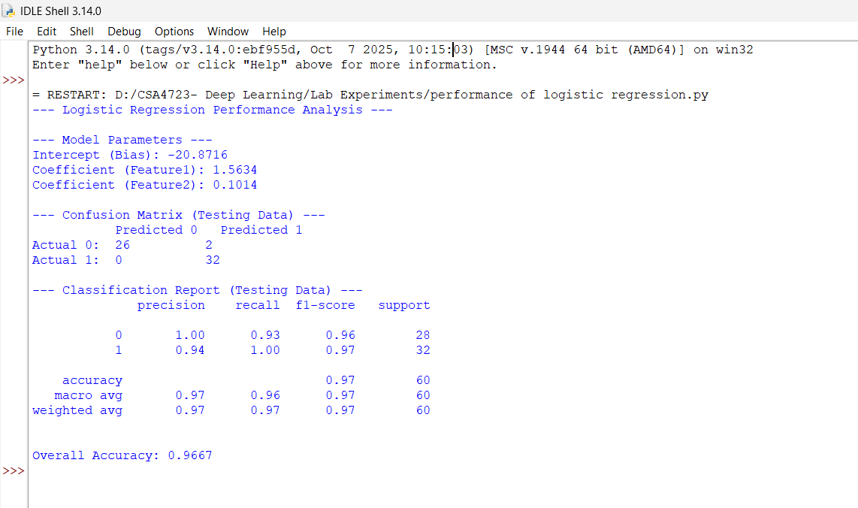

EXPERIMENT NO: 5
Demonstrating the performance of gradient descent algorithm using Python.

CODE:

import numpy as np
import matplotlib.pyplot as plt

# 1. Define the Objective Function (Cost Function)
# We will use a simple Quadratic function: J(w) = w^2 - 4w + 5
def cost_function(w):
return w**2 - 4*w + 5

# 2. Define the Gradient (Derivative of the Cost Function)
# J'(w) = 2w - 4
def gradient(w):
return 2*w - 4

# 3. Implement the Gradient Descent Algorithm
def gradient_descent(start_w, learning_rate, n_iterations):
w_history = [start_w]
cost_history = [cost_function(start_w)]
w = start_w

for i in range(n_iterations):
# Calculate the gradient (slope) at the current weight 'w'
grad = gradient(w)

# Update the weight: w = w - learning_rate * gradient
w = w - learning_rate * grad

# Record the new weight and cost
w_history.append(w)
cost_history.append(cost_function(w))

# Check for convergence (optional, for demonstration purposes)
if abs(grad) < 1e-6:
print(f"Converged at iteration {i+1}.")
break

return w, w_history, cost_history

# --- Execution Parameters ---
start_w = 0 # Initial guess for the weight
learning_rate = 0.1 # Step size (hyperparameter)
n_iterations = 20 # Number of steps

# 4. Run Gradient Descent
final_w, w_history, cost_history = gradient_descent(start_w, learning_rate, n_iterations)

# 5. Output Results and Plot Performance

print("--- Gradient Descent Performance Demonstration ---")
print(f"Optimal Weight (Analytic Minimum is w=2): {final_w:.4f}")
print(f"Minimum Cost (Analytic Minimum is J(w)=1): {cost_function(final_w):.4f}")
print(f"Total Iterations Run: {len(w_history) - 1}")

# Plotting the Cost Function and the Descent Path
w_range = np.linspace(-1, 5, 100)
cost_range = cost_function(w_range)

plt.figure(figsize=(10, 5))

# Plot 1: Cost Function vs. Weight (w) and the Path
plt.subplot(1, 2, 1)
plt.plot(w_range, cost_range, label='Cost Function $J(w)$', color='blue')
plt.plot(w_history, cost_history, 'ro--', label='Descent Path') # 'ro--' for red circles, dashed line
plt.scatter([final_w], [cost_function(final_w)], color='green', marker='o', s=100, label='Final Minimum')
plt.title('Gradient Descent Path')
plt.xlabel('Weight (w)')
plt.ylabel('Cost $J(w)$')
plt.grid(True, linestyle='--', alpha=0.6)
plt.legend()

# Plot 2: Cost vs. Iteration (Convergence Curve)
plt.subplot(1, 2, 2)
plt.plot(range(len(cost_history)), cost_history, 'm-')
plt.title('Cost vs. Iteration (Convergence)')
plt.xlabel('Iteration')
plt.ylabel('Cost $J(w)$')
plt.grid(True, linestyle='--', alpha=0.6)

plt.tight_layout()
plt.show()

OUTPUT:
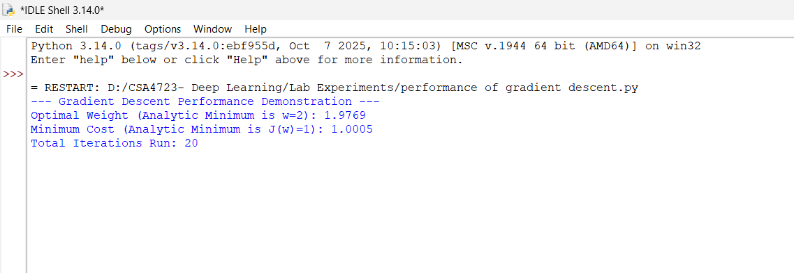

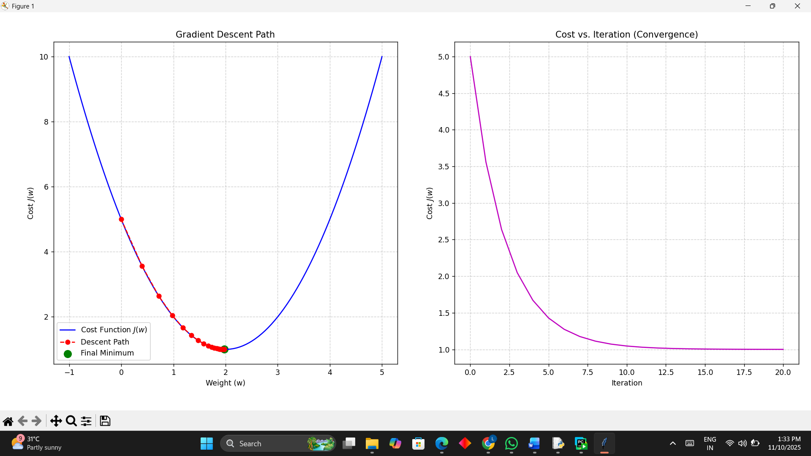
Exp-6
import cv2
import numpy as np
import matplotlib.pyplot as plt
import time
import urllib.request
url = 'https://upload.wikimedia.org/wikipedia/commons/7/7d/Dog_face.png'

headers = {'User-Agent': 'Mozilla/5.0 (Windows NT 10.0; Win64; x64) AppleWebKit/537.36 (KHTML, like Gecko) Chrome/58.0.3029.110 Safari/537.3'}
req = urllib.request.Request(url, headers=headers)

try:
with urllib.request.urlopen(req) as response, open('sample.jpg', 'wb') as out_file:
out_file.write(response.read())
print("Image downloaded successfully as 'sample.jpg'")
except urllib.error.HTTPError as e:
print(f"Error downloading image: HTTP Error {e.code} - {e.reason}")
print("The server denied access (403 Forbidden). Please check the URL or try a different image source.")
except Exception as e:
print(f"An unexpected error occurred during image download: {e}")

image = cv2.imread('sample.jpg')

if image is None:
print("Error: Could not load image. Please ensure 'sample.jpg' exists and is not corrupted, or if download failed.")
else:
gray = cv2.cvtColor(image, cv2.COLOR_BGR2GRAY)

start_time = time.time()

blur = cv2.GaussianBlur(gray, (5, 5), 0)
_, otsu_thresh = cv2.threshold(blur, 0, 255, cv2.THRESH_BINARY + cv2.THRESH_OTSU)

end_time = time.time()

processing_time = end_time - start_time
mse = np.mean((gray - otsu_thresh) ** 2)
psnr = 20 * np.log10(255 / np.sqrt(mse)) if mse != 0 else float('inf')

plt.figure(figsize=(10, 5))
plt.subplot(1, 3, 1)
plt.title('Original Image')
plt.imshow(cv2.cvtColor(image, cv2.COLOR_BGR2RGB))
plt.axis('off')

plt.subplot(1, 3, 2)
plt.title('Grayscale + Gaussian Blur')
plt.imshow(blur, cmap='gray')
plt.axis('off')

plt.subplot(1, 3, 3)
plt.title("Otsu's Thresholding")
plt.imshow(otsu_thresh, cmap='gray')
plt.axis('off')
plt.show()

print("===== Performance Verification ====")
print(f"Otsu's Threshold Value: {_}")
print(f"Processing Time: {processing_time:.4f} seconds")
print(f"PSNR (dB): {psnr:.2f}")
output:
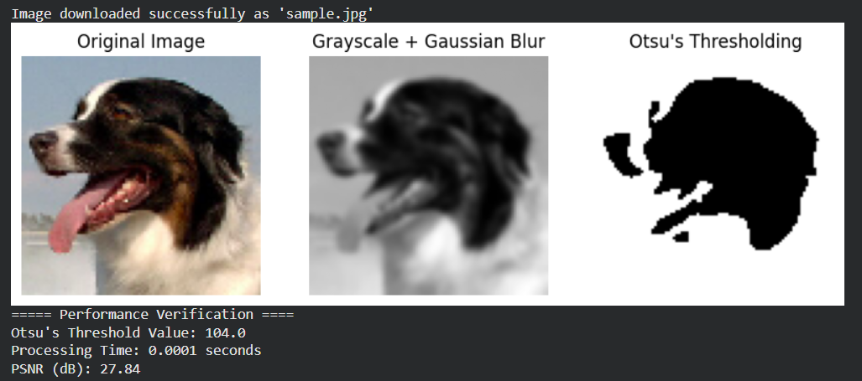
Exp-7
import cv2
import numpy as np
import matplotlib.pyplot as plt
import time

image = cv2.imread('sample.jpg')
gray = cv2.cvtColor(image, cv2.COLOR_BGR2GRAY)
start_time = time.time()
blur = cv2.GaussianBlur(gray, (5, 5), 0)
ret, thresh = cv2.threshold(blur, 0, 255, cv2.THRESH_BINARY_INV + cv2.THRESH_OTSU)
kernel = np.ones((3, 3), np.uint8)
opening = cv2.morphologyEx(thresh, cv2.MORPH_OPEN, kernel, iterations=2)
sure_bg = cv2.dilate(opening, kernel, iterations=3)
dist_transform = cv2.distanceTransform(opening, cv2.DIST_L2, 5)
ret, sure_fg = cv2.threshold(dist_transform, 0.7 * dist_transform.max(), 255, 0)
sure_fg = np.uint8(sure_fg)
unknown = cv2.subtract(sure_bg, sure_fg)
ret, markers = cv2.connectedComponents(sure_fg)
markers = markers + 1
markers[unknown == 255] = 0
markers = cv2.watershed(image, markers)
image[markers == -1] = [255, 0, 0]
end_time = time.time()
processing_time = end_time - start_time
mse = np.mean((gray - cv2.cvtColor(image, cv2.COLOR_BGR2GRAY)) ** 2)
psnr = 20 * np.log10(255 / np.sqrt(mse)) if mse != 0 else float('inf')
plt.figure(figsize=(10, 5))
plt.subplot(1, 3, 1)
plt.title('Original')
plt.imshow(cv2.cvtColor(cv2.imread('sample.jpg'), cv2.COLOR_BGR2RGB))
plt.axis('off')
plt.subplot(1, 3, 2)
plt.title('Thresholded')
plt.imshow(thresh, cmap='gray')
plt.axis('off')
plt.subplot(1, 3, 3)
plt.title('Watershed Result')
plt.imshow(cv2.cvtColor(image, cv2.COLOR_BGR2RGB))
plt.axis('off')
plt.show()
print("===== Performance Verification =====")
print(f"Processing Time: {processing_time:.4f} seconds")
print(f"PSNR (dB): {psnr:.2f}")
output:
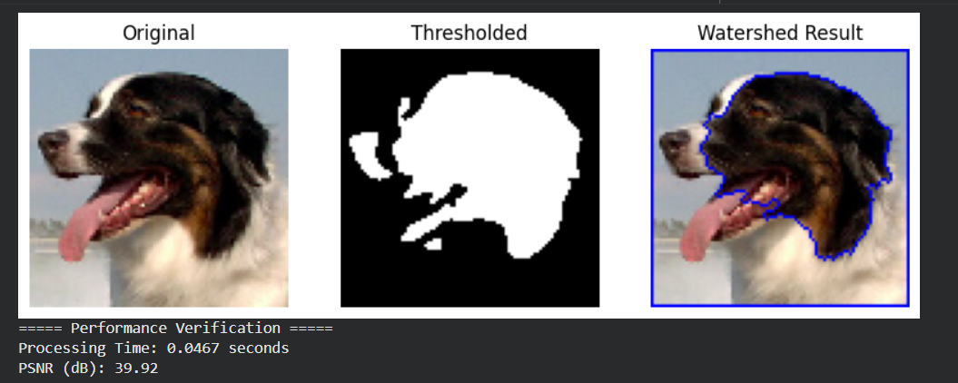
Exp-8
import tensorflow as tf
from tensorflow.keras.models import Sequential
from tensorflow.keras.layers import Dense
from tensorflow.keras.optimizers import Adam
from sklearn.datasets import make_moons
from sklearn.model_selection import train_test_split
from sklearn.preprocessing import StandardScaler
from sklearn.metrics import accuracy_score
import numpy as np

# Generate sample data (like the Playground)
X, y = make_moons(n_samples=1000, noise=0.2, random_state=42)
X = StandardScaler().fit_transform(X)
X_train, X_test, y_train, y_test = train_test_split(X, y, test_size=0.3, random_state=42)

# Try different configurations
learning_rates = [0.01, 0.001, 0.0001]
activations = ['relu', 'tanh', 'sigmoid']

for lr in learning_rates:
for act in activations:
print(f"\n===== MLP with learning_rate={lr}, activation={act} =====")

model = Sequential([
Dense(8, activation=act, input_shape=(2,)),
Dense(8, activation=act),
Dense(1, activation='sigmoid')
])

optimizer = Adam(learning_rate=lr)
model.compile(optimizer=optimizer, loss='binary_crossentropy', metrics=['accuracy'])

history = model.fit(X_train, y_train, epochs=50, batch_size=16, verbose=0)

y_pred = (model.predict(X_test) > 0.5).astype("int32")
acc = accuracy_score(y_test, y_pred)
print(f"Test Accuracy: {acc:.4f}")

output:
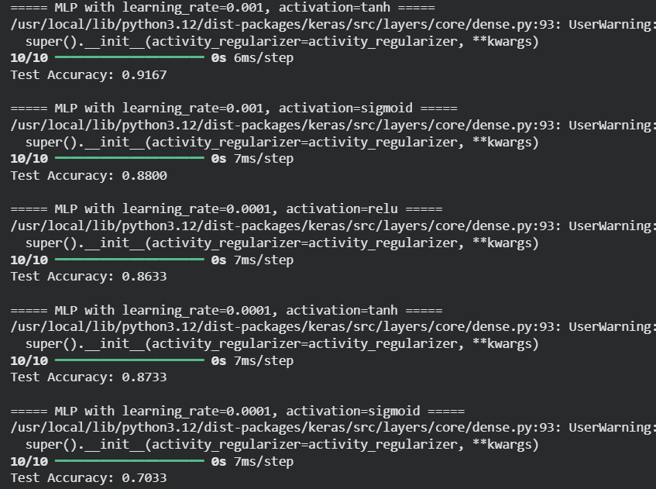
Exp-9
import tensorflow as tf
from tensorflow.keras.models import Sequential
from tensorflow.keras.layers import Dense
from tensorflow.keras.optimizers import Adam
from sklearn.datasets import make_moons
from sklearn.model_selection import train_test_split
from sklearn.preprocessing import StandardScaler
from sklearn.metrics import accuracy_score
import numpy as np
import pandas as pd

# Generate non-linear dataset (like Neural Network Playground)
X, y = make_moons(n_samples=1000, noise=0.2, random_state=42)
X = StandardScaler().fit_transform(X)
X_train, X_test, y_train, y_test = train_test_split(X, y, test_size=0.3, random_state=42)

# Hyperparameter options
hidden_layers = [1, 2, 3]
neurons = [4, 8, 16]
learning_rates = [0.01, 0.001]
activations = ['relu', 'tanh', 'sigmoid']

results = []

# Iterate through all combinations
for hl in hidden_layers:
for hn in neurons:
for lr in learning_rates:
for act in activations:
model = Sequential()
model.add(Dense(hn, activation=act, input_shape=(2,)))
for _ in range(hl - 1):
model.add(Dense(hn, activation=act))
model.add(Dense(1, activation='sigmoid'))

optimizer = Adam(learning_rate=lr)
model.compile(optimizer=optimizer, loss='binary_crossentropy', metrics=['accuracy'])
model.fit(X_train, y_train, epochs=50, batch_size=16, verbose=0)

y_pred = (model.predict(X_test) > 0.5).astype("int32")
acc = accuracy_score(y_test, y_pred)

results.append({
'Hidden_Layers': hl,
'Hidden_Neurons': hn,
'Learning_Rate': lr,
'Activation': act,
'Accuracy': acc
})

# Display performance table
df = pd.DataFrame(results)
print("\n===== Performance Evaluation of Neural Network Architectures =====")
print(df.sort_values(by='Accuracy', ascending=False).reset_index(drop=True))

output:
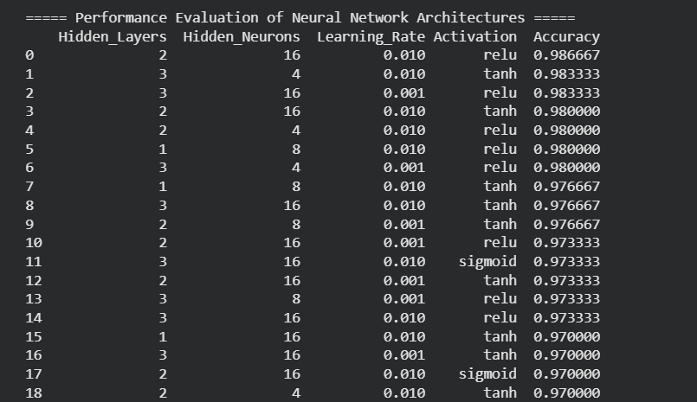
Exp-10
from sklearn.datasets import load_breast_cancer
from sklearn.model_selection import train_test_split
from sklearn.linear_model import LinearRegression
from sklearn.metrics import mean_squared_error, r2_score, accuracy_score
import numpy as np

data = load_breast_cancer()
X = data.data
y = data.target

X_train, X_test, y_train, y_test = train_test_split(X, y, test_size=0.3, random_state=42)

model = LinearRegression()
model.fit(X_train, y_train)
y_pred = model.predict(X_test)
y_pred_class = np.where(y_pred > 0.5, 1, 0)

mse = mean_squared_error(y_test, y_pred)
r2 = r2_score(y_test, y_pred)
acc = accuracy_score(y_test, y_pred_class)

print("Mean Squared Error:", mse)
print("R2 Score:", r2)
print("Accuracy:", acc)
output:
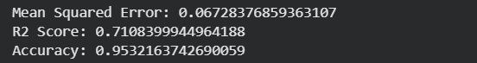
Exp-11
from sklearn.datasets import load_breast_cancer
from sklearn.model_selection import train_test_split
from sklearn.linear_model import LogisticRegression
from sklearn.metrics import accuracy_score, confusion_matrix, classification_report
data = load_breast_cancer()
X = data.data
y = data.target
X_train, X_test, y_train, y_test = train_test_split(X, y, test_size=0.3, random_state=42)
model = LogisticRegression(max_iter=10000)
model.fit(X_train, y_train)
y_pred = model.predict(X_test)
acc = accuracy_score(y_test, y_pred)
cm = confusion_matrix(y_test, y_pred)
cr = classification_report(y_test, y_pred)
print("Accuracy:", acc)
print("Confusion Matrix:\n", cm)
print("Classification Report:\n", cr)
output:
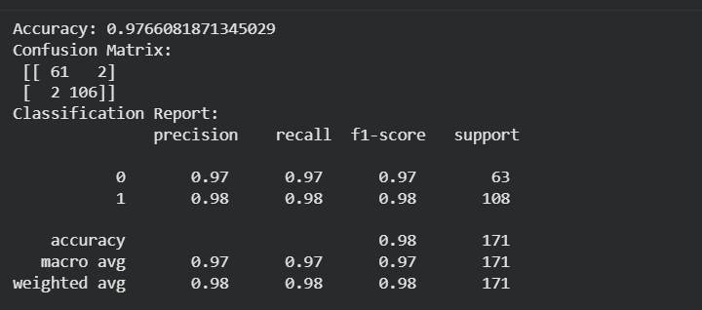
Exp-12
from sklearn.datasets import load_breast_cancer
from sklearn.model_selection import train_test_split
from sklearn.ensemble import RandomForestClassifier
from sklearn.metrics import accuracy_score, confusion_matrix, classification_report
data = load_breast_cancer()
X = data.data
y = data.target
X_train, X_test, y_train, y_test = train_test_split(X, y, test_size=0.3, random_state=42)
model = RandomForestClassifier(n_estimators=100, random_state=42)
model.fit(X_train, y_train)
y_pred = model.predict(X_test)
acc = accuracy_score(y_test, y_pred)
cm = confusion_matrix(y_test, y_pred)
cr = classification_report(y_test, y_pred)
print("Accuracy:", acc)
print("Confusion Matrix:\n", cm)
print("Classification Report:\n", cr)
output:
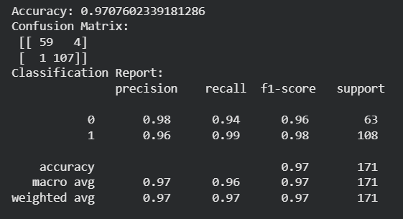
Exp-13
from sklearn.datasets import load_breast_cancer
from sklearn.model_selection import train_test_split
from sklearn.tree import DecisionTreeClassifier
from sklearn.metrics import accuracy_score, confusion_matrix, classification_report
data = load_breast_cancer()
X = data.data
y = data.target
X_train, X_test, y_train, y_test = train_test_split(X, y, test_size=0.3, random_state=42)
model = DecisionTreeClassifier(random_state=42)
model.fit(X_train, y_train)
y_pred = model.predict(X_test)
acc = accuracy_score(y_test, y_pred)
cm = confusion_matrix(y_test, y_pred)
cr = classification_report(y_test, y_pred)
print("Accuracy:", acc)
print("Confusion Matrix:\n", cm)
print("Classification Report:\n", cr)
output:

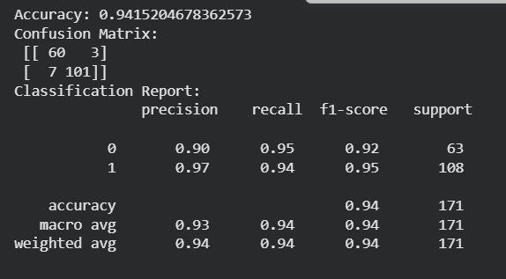
Exp-14
from sklearn.datasets import load_breast_cancer
from sklearn.model_selection import train_test_split
from sklearn.neighbors import KNeighborsClassifier
from sklearn.metrics import accuracy_score, confusion_matrix, classification_report
data = load_breast_cancer()
X = data.data
y = data.target
X_train, X_test, y_train, y_test = train_test_split(X, y, test_size=0.3, random_state=42)
model = KNeighborsClassifier(n_neighbors=5)
model.fit(X_train, y_train)
y_pred = model.predict(X_test)
acc = accuracy_score(y_test, y_pred)
cm = confusion_matrix(y_test, y_pred)
cr = classification_report(y_test, y_pred)
print("Accuracy:", acc)
print("Confusion Matrix:\n", cm)
print("Classification Report:\n", cr)
Output:
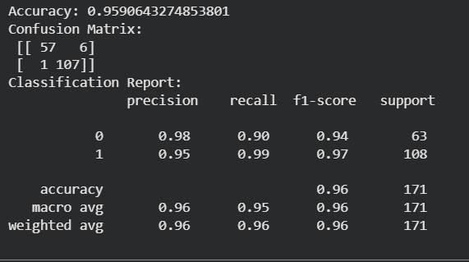
Exp-15
from sklearn.datasets import load_breast_cancer
from sklearn.model_selection import train_test_split
from sklearn.svm import SVC
from sklearn.metrics import accuracy_score, confusion_matrix, classification_report
data = load_breast_cancer()
X = data.data
y = data.target
X_train, X_test, y_train, y_test = train_test_split(X, y, test_size=0.3, random_state=42)
model = SVC(kernel='linear')
model.fit(X_train, y_train)
y_pred = model.predict(X_test)
acc = accuracy_score(y_test, y_pred)
cm = confusion_matrix(y_test, y_pred)
cr = classification_report(y_test, y_pred)
print("Accuracy:", acc)
print("Confusion Matrix:\n", cm)
print("Classification Report:\n", cr)
output:
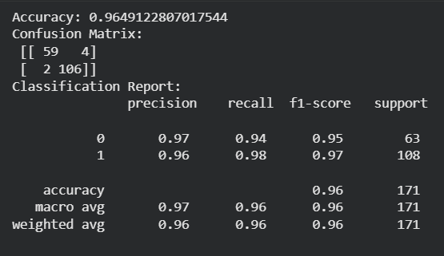

Exp-16
import tensorflow as tf
from tensorflow.keras.datasets import mnist
from tensorflow.keras.models import Sequential
from tensorflow.keras.layers import Dense, Flatten
from tensorflow.keras.utils import to_categorical

(x_train, y_train), (x_test, y_test) = mnist.load_data()
x_train = x_train/255.0
x_test = x_test/255.0
y_train = to_categorical(y_train)
y_test = to_categorical(y_test)

def build_model(lr, units, activation):
model = Sequential()
model.add(Flatten(input_shape=(28,28)))
model.add(Dense(units, activation=activation))
model.add(Dense(10, activation='softmax'))
optimizer = tf.keras.optimizers.Adam(learning_rate=lr)
model.compile(optimizer=optimizer, loss='categorical_crossentropy', metrics=['accuracy'])
return model

params = [
(0.001, 64, 'relu'),
(0.0005, 128, 'relu'),
(0.001, 128, 'tanh')
]

for lr, units, activation in params:
model = build_model(lr, units, activation)
model.fit(x_train, y_train, epochs=3, batch_size=128, verbose=0)
loss, acc = model.evaluate(x_test, y_test, verbose=0)
print(lr, units, activation, acc)

output:
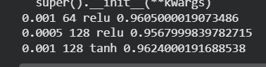

Exp-17
import tensorflow as tf
from tensorflow.keras import layers, models
from tensorflow.keras.datasets import cifar10
from tensorflow.keras.utils import to_categorical
import numpy as np

(x,y),(xt,yt)=cifar10.load_data()
mask=np.isin(y.flatten(),[0,1])
x=x[mask].astype("float32")/255.0
y=(y[mask].flatten()==1).astype(int)
maskt=np.isin(yt.flatten(),[0,1])
xt=xt[maskt].astype("float32")/255.0
yt=(yt[maskt].flatten()==1).astype(int)
y=to_categorical(y,2)
yt=to_categorical(yt,2)

model=models.Sequential()
model.add(layers.Input(shape=(32,32,3)))
model.add(layers.Conv2D(32,3,activation="relu"))
model.add(layers.MaxPooling2D())
model.add(layers.Conv2D(64,3,activation="relu"))
model.add(layers.Flatten())
model.add(layers.Dense(64,activation="relu"))
model.add(layers.Dense(2,activation="softmax"))
model.compile(optimizer="adam",loss="categorical_crossentropy",metrics=["accuracy"])
model.fit(x,y,epochs=3,batch_size=32,verbose=0)
print(model.evaluate(xt,yt))
output:
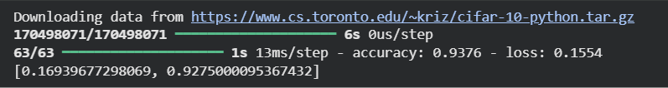

Exp-18
import tensorflow as tf
from tensorflow.keras import layers,models,optimizers
from tensorflow.keras.datasets import cifar10
from tensorflow.keras.utils import to_categorical
import numpy as np

(x,y),(xt,yt)=cifar10.load_data()
mask=np.isin(y.flatten(),[0,1])
x=x[mask].astype("float32")/255.0
y=(y[mask].flatten()==1).astype(int)
maskt=np.isin(yt.flatten(),[0,1])
xt=xt[maskt].astype("float32")/255.0
yt=(yt[maskt].flatten()==1).astype(int)
y=to_categorical(y,2)
yt=to_categorical(yt,2)

def cnn(act,lr,opt):
if opt=="adam": o=optimizers.Adam(lr)
elif opt=="sgd": o=optimizers.SGD(lr)
else: o=optimizers.RMSprop(lr)
model=models.Sequential([
layers.Conv2D(32,3,activation=act,input_shape=(32,32,3)),
layers.MaxPooling2D(),
layers.Conv2D(64,3,activation=act),
layers.Flatten(),
layers.Dense(128,activation=act),
layers.Dense(2,activation="softmax")
])
model.compile(optimizer=o,loss="categorical_crossentropy",metrics=["accuracy"])
return model

for batch in [16,32]:
for act in ["relu","tanh"]:
for lr in [0.001,0.0005]:
for opt in ["adam","sgd"]:
m=cnn(act,lr,opt)
m.fit(x,y,epochs=2,batch_size=batch,verbose=0)
print(batch,act,lr,opt,m.evaluate(xt,yt,verbose=0))

output:
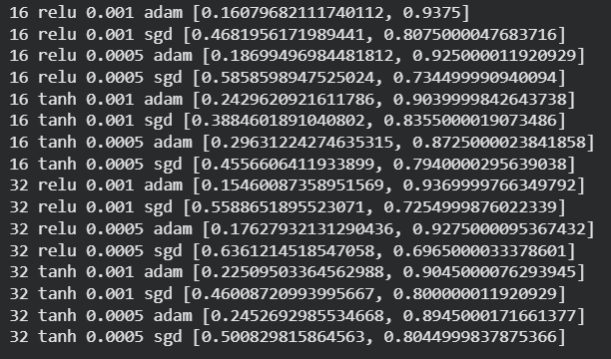

Exp-19
import numpy as np
import tensorflow as tf
from tensorflow.keras import layers,models

def data(n=100,sz=64):
imgs=[]
masks=[]
for _ in range(n):
img=np.zeros((sz,sz,3))
mask=np.zeros((sz,sz,1))
cx=np.random.randint(10,54)
cy=np.random.randint(10,54)
r=np.random.randint(5,12)
for i in range(sz):
for j in range(sz):
if (i-cx)**2+(j-cy)**2<=r*r:
mask[i,j]=1
img[i,j]=np.random.rand(3)
imgs.append(img)
masks.append(mask)
return np.array(imgs),np.array(masks)

x,y=data(200)
xt,yt=data(50)

def unet():
i=layers.Input((64,64,3))
c1=layers.Conv2D(16,3,activation="relu",padding="same")(i)
p1=layers.MaxPooling2D()(c1)
c2=layers.Conv2D(32,3,activation="relu",padding="same")(p1)
p2=layers.MaxPooling2D()(c2)
c3=layers.Conv2D(64,3,activation="relu",padding="same")(p2)
u1=layers.UpSampling2D()(c3)
m1=layers.concatenate([u1,c2])
c4=layers.Conv2D(32,3,activation="relu",padding="same")(m1)
u2=layers.UpSampling2D()(c4)
m2=layers.concatenate([u2,c1])
c5=layers.Conv2D(16,3,activation="relu",padding="same")(m2)
o=layers.Conv2D(1,1,activation="sigmoid")(c5)
m=models.Model(i,o)
m.compile(optimizer="adam",loss="binary_crossentropy",metrics=["accuracy"])
return m

m=unet()
m.fit(x,y,epochs=5,batch_size=16,verbose=0)
print(m.evaluate(xt,yt))

output:

Exp-20
from sklearn.neural_network import BernoulliRBM
from tensorflow.keras.datasets import imdb
from tensorflow.keras.preprocessing import sequence
from tensorflow.keras import models,layers
import numpy as np

from tensorflow.keras.datasets import mnist
(x,y),(xt,yt)=mnist.load_data()
x=x.reshape((-1,784))>0.5
rbm=BernoulliRBM(n_components=256,learning_rate=0.01,n_iter=5)
rbm.fit(x[:3000])
print(np.mean((rbm.transform(x[:1000]))))

max_features=20000
(xtr,ytr),(xte,yte)=imdb.load_data(num_words=max_features)
xtr=sequence.pad_sequences(xtr,200)
xte=sequence.pad_sequences(xte,200)

def net(t):
m=models.Sequential()
m.add(layers.Embedding(max_features,128,input_length=200))
if t=="rnn": m.add(layers.SimpleRNN(64))
else: m.add(layers.LSTM(64))
m.add(layers.Dense(1,activation="sigmoid"))
m.compile(optimizer="adam",loss="binary_crossentropy",metrics=["accuracy"])
return m

r=net("rnn")
r.fit(xtr[:3000],ytr[:3000],epochs=2,batch_size=64,verbose=0)
print(r.evaluate(xte[:1000],yte[:1000],verbose=0))

l=net("lstm")
l.fit(xtr[:3000],ytr[:3000],epochs=2,batch_size=64,verbose=0)
print(l.evaluate(xte[:1000],yte[:1000],verbose=0))
output:
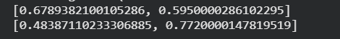

Exp-21
from sklearn.datasets import make_classification
from sklearn.model_selection import train_test_split
from sklearn.preprocessing import StandardScaler
from tensorflow.keras import models,layers
import numpy as np

x,y=make_classification(2000,20,n_classes=2,n_informative=10)
xtr,xte,ytr,yte=train_test_split(x,y,test_size=0.3)
sc=StandardScaler()
xtr=sc.fit_transform(xtr)
xte=sc.transform(xte)

m=models.Sequential([
layers.Dense(64,activation="relu",input_shape=(20,)),
layers.Dense(2,activation="softmax")
])
m.compile(optimizer="adam",loss="sparse_categorical_crossentropy",metrics=["accuracy"])
m.fit(xtr,ytr,epochs=5,batch_size=32,verbose=0)
print(m.evaluate(xte,yte))
output:
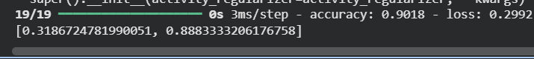

Exp-22
from sklearn.datasets import make_classification
from sklearn.model_selection import train_test_split
from sklearn.preprocessing import StandardScaler
from tensorflow.keras import models,layers
import numpy as np

x,y=make_classification(2000,20,n_classes=3,n_informative=15)
xtr,xte,ytr,yte=train_test_split(x,y,test_size=0.3)
sc=StandardScaler()
xtr=sc.fit_transform(xtr)
xte=sc.transform(xte)

m=models.Sequential([
layers.Dense(128,activation="relu",input_shape=(20,)),
layers.Dense(3,activation="softmax")
])
m.compile(optimizer="adam",loss="sparse_categorical_crossentropy",metrics=["accuracy"])
m.fit(xtr,ytr,epochs=5,batch_size=32,verbose=0)
print(m.evaluate(xte,yte))
output:
Exp-23
from sklearn.datasets import make_circles
from sklearn.model_selection import train_test_split
from sklearn.neighbors import KNeighborsClassifier

x,y=make_circles(n_samples=1000,factor=0.4,noise=0.05)
xtr,xte,ytr,yte=train_test_split(x,y,test_size=0.3)
model=KNeighborsClassifier(n_neighbors=5)
model.fit(xtr,ytr)
print(model.score(xte,yte))
output:

Exp-24
import numpy as np
import math
from sklearn.model_selection import train_test_split
from tensorflow.keras import models,layers

def spiral(n):
X=np.zeros((n,2))
y=np.zeros(n,dtype=int)
for i in range(n):
r=i/(n/2)
t=1.75*math.pi*r+np.random.randn()*0.2
X[i]=[r*math.cos(t),r*math.sin(t)]
y[i]=int(t%(2*math.pi)>math.pi)
return X,y

x,y=spiral(1500)
xtr,xte,ytr,yte=train_test_split(x,y,test_size=0.3)

m=models.Sequential([
layers.Dense(64,activation="relu",input_shape=(2,)),
layers.Dense(2,activation="softmax")
])
m.compile(optimizer="adam",loss="sparse_categorical_crossentropy",metrics=["accuracy"])
m.fit(xtr,ytr,epochs=40,batch_size=32,verbose=0)
print(m.evaluate(xte,yte))
output:
Exp-25
from tensorflow.keras import models,layers
from tensorflow.keras.datasets import mnist

(x,y),(xt,yt)=mnist.load_data()
x=x.reshape((-1,784)).astype("float32")/255
xt=xt.reshape((-1,784)).astype("float32")/255

acts=["relu","tanh","sigmoid"]
structs=[[128],[256,128],[512,256,128]]

for a in acts:
for s in structs:
m=models.Sequential()
m.add(layers.Input(shape=(784,)))
for u in s:
m.add(layers.Dense(u,activation=a))
m.add(layers.Dense(10,activation="softmax"))
m.compile(optimizer="adam",loss="sparse_categorical_crossentropy",metrics=["accuracy"])
m.fit(x,y,epochs=2,batch_size=256,verbose=0)
print(a,s,m.evaluate(xt,yt,verbose=0))
output:
